AUTISM PREDICTION USING DEEP LEARNING

**A SOCIALLY RELEVANT MINI PROJECT REPORT**

***Submitted by***

# TAMILARASI S [211423104679]

**THARUNI R [211423104692]**

***in partial fulfillment for the award of the degree of***

# BACHELOR OF ENGINEERING

**in**

**COMPUTER SCIENCE AND ENGINEERING**



**PANIMALAR ENGINEERING COLLEGE**

**(An Autonomous Institution, Affiliated to Anna University, Chennai)**

**OCTOBER 2025**

**BONAFIDE CERTIFICATE**

Certified that this project report **“AUTISM PREDICTION USING DEEP LEARNING”** is the bonafide work of **TAMILARASI S (211423104679), THARUNI R (211423104692)** who carried out the project work under my supervision.

**Signature of the HOD Signature of the Supervisor**

**Dr L. JABASHEELA, M.E., Ph.D., Dr. V. SATHIYA, M.E., Ph.D., PROFESSOR AND HEAD, PROFESSOR,**

**Department of CSE Department of CSE**

**Panimalar Engineering College, Panimalar Engineering College,**

**Chennai – 600 123 Chennai – 600 123**

Submitted for 23CS1512 – Socially Relevant Mini Project Viva-Voce Examination held on...........................

**INTERNAL EXAMINER EXTERNAL EXAMINER**

**DECLARATION BY THE STUDENT**

### We THARUNI R (211423104692), TAMILARASI S (211423104679) hereby

declare that this project report titled **“AUTISM PREDICTION USING DEEP LEARNING”** under the guidance of **Dr. V. SATHIYA, M.E., PH.D.,** is the original work done by us and we have not plagiarized or submitted to any other degree in any university by us.

**SIGNATURE OF THE STUDENTS**

**TAMILARASI S (211423104679)**

**THARUNI R (211423104692)**

**ACKNOWLEDGEMENT**

We would like to express our deep gratitude to our respected **Secretary and Correspondent Dr. P. CHINNADURAI, M.A., Ph.D.,** for his kind words and enthusiastic motivation, which inspired us a lot in completing this project.

We express our sincere thanks to our **Directors Tmt. C. VIJAYARAJESWARI**, **Dr. C. SAKTHI KUMAR, M.E., Ph.D.,** and Dr. **SARANYASREE SAKTHI**

**KUMAR, B.E., M.B.A., Ph.D.,** for providing us with the necessary facilities to undertake this project.

We also express our gratitude to our **Principal Dr. K. Mani, M.E., Ph.D.,** who facilitated us in completing the project. We sincerely thank the **Head of the Department, Dr. L. JABASHEELA, M.E., Ph.D.,** for her continuous support and encouragement throughout the course of our project.

We would like to express our sincere gratitude to our **Project Coordinators, Dr. V. SUBEDHA**, **M.E., Ph.D., Mrs. S. SHARMILA, M.E., [Ph.D..,]**, and our

**Project Guide, Dr. V. SATHIYA, M.E., Ph.D.,** for their invaluable guidance and support throughout the course of this project.

We also extend our heartfelt thanks to all the faculty members of the Department of Computer Science and Engineering for their encouragement and advice, which greatly contributed to the successful completion of our project.

**TAMILARASI S (211423104679)**

**THARUNI R (211423104692)**

**ABSTRACT**

Autism Spectrum Disorder (ASD) is a neurodevelopmental condition characterized by challenges in communication, social interaction, and repetitive behaviors. Early identification is essential to provide timely interventions that improve developmental outcomes and quality of life. Conventional diagnostic methods often rely on clinical expertise and behavioral observation, which can be subjective and time-consuming. Artificial intelligence (AI) and deep learning techniques offer automated, objective, and scalable solutions for early autism screening. Video-based analysis is applied to detect autism-related behavioral patterns by examining facial expressions, eye gaze, body movements, and interactions. Videos are divided into frames and preprocessed through normalization, resizing, and enhancement to ensure consistency. Spatial and temporal feature extraction helps capture subtle cues associated with ASD. Classification techniques distinguish between autistic and non-autistic behaviors, while performance is evaluated using accuracy, precision, recall, F1-score, and AUC metrics. This automated, real-time, and non-invasive approach supports clinicians in early detection and decision-making. It minimizes human error and provides continuous behavioral monitoring, making it suitable for large-scale screening applications. The method enables faster diagnosis in remote or resource-limited areas where access to specialists is limited. Integration with AI-driven analytics allows better visualization and understanding of behavioral differences across individuals. The combination of technology and healthcare helps bridge the gap between clinical expertise and accessibility, improving diagnostic accuracy and reducing delays in intervention. The integration of AI and computer vision advances healthcare by enabling accessible, affordable, and inclusive screening tools suitable for diverse cultural and clinical contexts. By reducing subjectivity and enhancing efficiency, this technology-driven method promotes early autism detection and contributes to improved developmental outcomes for individuals with autism and their families.

**TABLE OF CONTENTS**

**CHAPTER NO. TITLE PAGE NO.**

|  |  |
| --- | --- |
| **ABSTRACT**  **LIST OF FIGURES**  **LIST OF ABBREVIATIONS**  **1. INTRODUCTION** | **v viii ix**  **1** |
| 1.1 Overview | 1 |
| 1.2 Problem Definition | 2 |
| **2. LITERATURE SURVEY** | **3** |
| **3. SYSTEM ANALYSIS** | **6** |
| 3.1 Existing System | 6 |
| 3.2 Proposed System | 6 |
| 3.3 Implementation Environment | 7 |
| **4. SYSTEM DESIGN** | **8** |
| 4.1 Activity Diagram | 8 |
| 4.2 Deployment Diagram | 9 |
| 4.3 Use Case Diagram | 11 |
| 4.4 Sequence Diagram | 12 |
| 4.5 Class Diagram | 14 |
| **5. SYSTEM ARCHITECTURE** | **16** |
| 5.1 Data Collection Module | 16 |
| 5.2 Input Design | 18 |
| 5.3 Output Design | 20 |

|  |  |
| --- | --- |
| **6. SYSTEM IMPLEMENTATION** | **21** |
| 6.1 Source code | 21 |
| **7. SYSTEM TESTING** | **25** |
| 7.1 Experimental Setup | 25 |
| 7.2 Evaluation Metrics | 25 |
| 7.3 Quantitative Results | 26 |
| 7.4 Variety Specific Predict | 27 |
| 7.5 Discussion | 29 |
| **8. CONCLUSION** | **28** |
| 8.1 Conclusion | 28 |
| 8.2 Future Work | 29 |
| **9. APPENDICES** | **31** |
| A1 – SDG goals | 31 |
| A2 – Sample Screenshots | 33 |
| A3 – Paper Publication | 35 |
| A4 – Plagiarism Report | 40 |
| **10. REFERENCES** | **49** |

|  |  |  |
| --- | --- | --- |
|  | **LIST OF FIGURES** |  |
| **FIGURE NO.** | **FIGURE DESCRIPTION** | **PAGE NO.** |
| 4.1 | Activity Diagram for Autism Prediction | 8 |
| 4.2 | Deployment Diagram for Autism Prediction | 9 |
| 4.3 | Use Case Diagram for Autism Prediction | 11 |
| 4.4 | Sequence Diagram for Autism Prediction | 12 |
| 4.5 | Class Diagram for Autism Prediction | 14 |
| 5.1 | Data Collection Process flow for autism prediction | 16 |
| A2.1 | Screenshot of the Output | 33 |
| A2.2 | Screenshot of the popup video | 33 |
| A2.3 | Screenshot for dataset | 34 |

**LIST OF ABBREVIATIONS**

|  |  |
| --- | --- |
| **S. NO** | **ABBREVIATIONS** |
| 1 | ASD – Autism Spectrum Disorder |
| 2 | CNN – Convolutional Neural Network |
| 3 | RNN – Recurrent Neural Network |
| 4 | LSTM – Long Short – Term Memory |
| 5 | VGG – Visual Geometry Group |
| 6 | ML – Machine Learning |
| 7 | ADOS – Autism Diagnostic Observation Schedule |
| 8 | UML – Unified Modeling Language |
| 9 | ADI – R – Autism Diagnostic Interview - Revised |

* 1. **OVERVIEW**

**CHAPTER 1**

**INTRODUCTION**

Autism Spectrum Disorder (ASD) is a developmental condition that significantly influences communication, social behavior, and cognitive functioning. Early detection plays a crucial role in improving learning outcomes and enhancing the overall quality of life for individuals with ASD. Traditional diagnostic methods, however, are often subjective, heavily reliant on expert evaluations, and time- intensive. To overcome these limitations, an automated autism prediction system based on deep learning and video analysis is explored.

Autism Prediction utilizes advanced deep learning architectures capable of analyzing both spatial and temporal patterns in video data to identify behavioral markers associated with autism. Video-based observations can capture essential behavioral cues such as facial expressions, eye gaze, body movements, and response patterns key indicators in autism assessment. The analytical process involves preprocessing stages, including frame extraction, normalization, and feature enhancement. Convolutional Neural Networks (CNNs) are employed for spatial feature extraction, while Recurrent Neural Networks (RNNs) or Long Short-Term Memory (LSTM) networks are used to learn temporal sequences. This approach enables the detection of subtle behavioral variations that may signify ASD-related characteristics.

The framework is trained and validated using benchmark video datasets, with performance evaluated through standard metrics such as accuracy, precision, recall, and F1-score.

# PROBLEM STATEMENT

Autism Spectrum Disorder (ASD) is a neurodevelopmental condition that affects communication, social interaction, and behavior. Early identification is crucial to ensure timely intervention and improve long-term outcomes. However, current diagnostic practices primarily depend on clinical observations, parental questionnaires, and professional expertise. These methods are often time- consuming, subjective, and limited in accessibility, particularly in resource- constrained or remote areas, resulting in delayed diagnosis and intervention.

A major challenge in the field is the absence of automated, reliable, and scalable systems capable of assisting healthcare professionals in predicting autism at an early stage. Video recordings offer a rich source of behavioral and non-verbal information such as eye gaze, gestures, and body movements that are critical for autism assessment. Nevertheless, manual analysis of these videos is labor-intensive and susceptible to human bias, reducing consistency and efficiency in diagnosis.

To address these limitations, a deep learning-based system is proposed to automatically analyze video data for autism prediction. By extracting and interpreting both spatial and temporal features, the system is designed to identify subtle behavioral markers associated with ASD. This approach aims to enhance the accuracy, objectivity, and accessibility of autism screening, thereby supporting clinicians, minimizing diagnostic delays, and promoting early interventions for children at risk. The system can also handle large-scale datasets efficiently, enabling population-wide screening and longitudinal monitoring. Moreover, integration of explainable AI techniques can provide transparent insights into behavioral patterns, building trust among clinicians and caregivers. Overall, this method represents a promising step toward transforming autism diagnostics through technology-driven solutions.

# CHAPTER 2 LITERATURE SURVEY

Early studies on automated autism prediction highlighted the feasibility of using everyday video data for diagnostic support. Tariq et al. (2018) conducted one of the pioneering works demonstrating that short, home-recorded videos could effectively be used to predict Autism Spectrum Disorder (ASD) through machine learning. Their approach analyzed non-verbal behavioral cues such as gaze direction, facial expressions, gestures, and movement patterns. The study revealed that even short video segments captured meaningful behavioral differences between autistic children and typically developing peers. This research underscored the potential of automated video-based tools as non- invasive, low-cost, and accessible aids for clinical autism assessments, laying the groundwork for subsequent artificial intelligence (AI)-driven studies in behavioral health screening.

Building upon this foundation, Abbas et al. (2020) explored deep learning approaches using facial image datasets to identify autism traits. The researchers employed transfer learning on well-established Convolutional Neural Network (CNN) architectures such as VGG and ResNet, which extracted fine-grained features related to facial structure and expressions commonly associated with ASD. Their findings demonstrated that CNN-based models could autonomously learn complex visual representations without the need for handcrafted features, achieving promising accuracy. This work marked a significant advancement in automating autism detection through facial analysis and bridged the gap between traditional image processing techniques and modern deep learning methodologies.

Recognizing the limitations of static image models, Egger et al. (2021) emphasized the importance of temporal dynamics in autism prediction. They proposed a hybrid CNN-LSTM framework that combined spatial and temporal

feature learning, enabling the model to capture both appearance-based cues and time-dependent behavioral patterns from home videos. This approach reflected real-world behavioral sequences such as repetitive movements or delayed responses that are characteristic of ASD. The integration of temporal learning significantly enhanced classification performance and highlighted the importance of analyzing continuous behavioral patterns rather than isolated frames to improve diagnostic reliability. Moreover, the hybrid framework allowed for end-to-end learning of complex behavioral sequences without extensive manual annotation, improving scalability for larger datasets. By capturing subtle temporal correlations, the model could differentiate between typical and atypical behaviors more effectively. The study also demonstrated that combining spatial and temporal features increased interpretability by showing which sequences contributed most to predictions. Overall, this approach underscored the critical role of temporal modeling in creating robust, accurate, and clinically meaningful autism detection systems.

Expanding the scope of analysis beyond facial expressions, Hashemi et al. (2022) introduced skeleton-based and pose estimation techniques using methods such as OpenPose to detect autism-related behaviors. Their system extracted skeletal key points from video frames to analyze motor behaviors, body postures, and movement patterns that often differ in children with ASD. By focusing on geometric motion rather than raw pixel data, this approach offered improved interpretability and robustness, reducing the influence of environmental factors such as lighting and background variations. The study demonstrated that pose-based motion analysis could effectively identify atypical motor coordination and posture, key non-verbal indicators of autism, and reinforced the importance of full-body behavioral assessment in ASD prediction. Additionally, combining pose-based features with temporal modeling allowed the system to capture dynamic movement patterns over time, providing richer behavioral insights. This approach also facilitated automated

large-scale analysis, reducing reliance on labor-intensive manual annotation. Overall, the study highlighted the potential of integrating skeletal motion data into AI-driven diagnostic frameworks to improve early detection and monitoring of ASD.

More recent research has focused on multimodal and transformer-based learning frameworks that integrate diverse behavioral signals to enhance predictive performance. Kaur et al. (2022) developed a multimodal model that combined video and audio data using an ensemble of CNNs, RNNs, and traditional classifiers. This approach analyzed both visual cues, such as facial expressions and gestures, and auditory features, such as speech tone and rhythm, thereby capturing multiple dimensions of social behavior. Sapiński et al. (2023) further advanced this direction by applying transformer architectures capable of modeling long behavioral sequences through self-attention mechanisms, enabling the detection of nuanced temporal dependencies and subtle behavioral variations. These models also facilitated end-to-end learning, reducing the need for manual feature engineering and improving scalability for large datasets. While transformer-based models achieved superior performance compared to traditional RNNs, Li et al. (2023) noted persisting challenges, including limited dataset diversity, overfitting, and lack of interpretability. Addressing these issues, recent studies have explored techniques such as data augmentation, multimodal fusion strategies, and explainable AI methods to enhance robustness and transparency. Despite these obstacles, multimodal and transformer-based approaches represent a promising frontier for reliable, explainable, and accessible AI-driven autism assessment systems, with the potential to support early detection, personalized interventions, and large-scale screening initiatives.

**CHAPTER 3**

**SYSTEM ANALYSIS**

* 1. **EXISTING SYSTEM**

Traditional autism diagnosis systems rely heavily on clinical observation, standardized behavioral tests, and parental questionnaires such as the Autism Diagnostic Observation Schedule (ADOS) and Autism Diagnostic Interview- Revised (ADI-R). While effective, these methods are time-consuming, costly, and highly dependent on the expertise of trained professionals. In recent years, some automated systems have been developed using machine learning on static images or small behavioral datasets, but these approaches are limited in their ability to capture temporal patterns of behavior, often lack scalability, and are not widely accessible for early screening in diverse populations.

# PROPOSED SYSTEM

The proposed system introduces a deep learning-based framework that uses video analysis to predict autism by automatically extracting both spatial and temporal features. Convolutional Neural Networks (CNNs) are employed to detect facial expressions, gaze, and posture from video frames, while Recurrent Neural Networks (RNNs) or Long Short-Term Memory (LSTM) networks capture sequential behavioral cues over time. This hybrid approach enables the framework to identify subtle, non-verbal markers of autism with greater accuracy. It is designed to be non-invasive, scalable, and capable of real-time analysis, providing clinicians with an efficient, objective, and accessible tool for early autism screening.

Additionally, the proposed system can process large volumes of video data, enabling population-level screening and longitudinal monitoring of developmental

progress. Integration of explainable AI techniques allows clinicians to visualize attention maps and understand which behavioral cues influence predictions, increasing transparency and trust. By combining spatial, temporal, and multimodal features, the approach enhances diagnostic reliability and reduces human bias, potentially transforming early detection and intervention strategies for children at risk of ASD. The framework also supports adaptation to diverse environments and age groups, ensuring broader applicability and accessibility.

# IMPLEMENTATION AND ENVIRONMENT SOFTWARE REQUIREMENTS

* + - Windows 10
    - Python 3.7 or above
    - TensorFlow / Keras or PyTorch
    - OpenCV, NumPy, Pandas, Matplotlib, Scikit-learn
    - Jupyter Notebook / PyCharm / VS Code
    - Local or cloud storage for video datasets
    - Git/GitHub for version control

# HARDWARE REQUIREMENTS

* + - Processor: Intel i5 or above
    - Memory (RAM): 16 GB
    - Hard Drive: 32 GB Internet Connection

# CHAPTER 4 SYSTEM DESIGN

* 1. **ACTIVITY DIAGRAM**

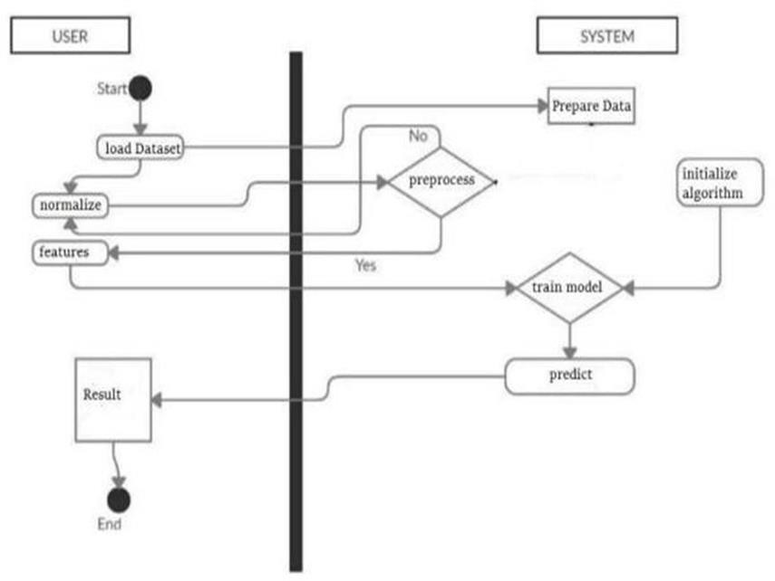

* 1. **Activity diagram for Autism Prediction**

Activity Diagram outlines the complete workflow for the Autism Prediction System, clearly separating responsibilities between the user and the system using a swimlane. The process initiates with the user starting the system and performing the load Dataset activity. Following this, the flow moves to a key decision point where the system checks if the data requires preprocessing. If pre-processing is needed (Yes), the system executes the Prepare Data activity before the flow continues. If not needed (No), the system proceeds directly. Subsequently, the

user performs critical data preparation steps: normalize (data scaling) and features (feature extraction/selection). Once the data is prepared, the system must initialize algorithm concurrently with the flow entering the model training phase. The diagram then shows a decision (implicitly assumed to be to proceed) to train model, which is a system function. Upon successful training, the system executes the predict activity. Finally, the outcome, labeled Result, is passed back to the user, marking the End of the system's operation. This sequence highlights a standard machine learning pipeline, moving from data acquisition and preparation through to model prediction.

# DEPLOYMENT DIAGRAM

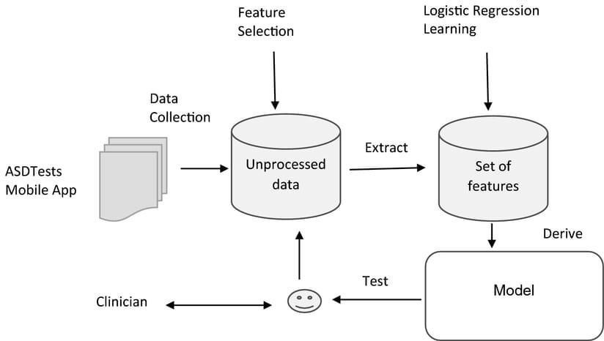

### Deployment diagram for Autism Prediction

**User**

* Represents the clinician, patient, or researcher who interacts with the system.
* They initiate requests, such as submitting questionnaire data or accessing predictions.

### Frontend (Web Interface)

* The user-facing application, usually a web or mobile dashboard.
* Handles input (e.g., patient responses, medical records) and displays results.
* Provides authentication and user-friendly visualization of predictions.

### Backend (API Server)

* The core processing unit that connects the frontend with the deep learning model.
* Manages data requests, enforces validation, and handles business logic.
* Ensures security, privacy, and compliance during data transfer.

### Deep Learning Model (Neural Network)

* The deployed autism prediction model trained on structured/unstructured data.
* Receives processed inputs from the backend and generates prediction outputs (e.g., risk scores, likelihood of ASD traits).
* Runs inside a model-serving environment (e.g., TensorFlow Serving, TorchServe, or a containerized microservice).
* Utilizes multiple hidden layers to learn complex behavioral and neurological patterns associated with Autism Spectrum Disorder (ASD).
* Applies feature extraction and representation learning to automatically identify significant patterns from images, videos, or clinical records.
* Incorporates activation functions such as ReLU or sigmoid to introduce non-linearity and improve learning performance.

# USE CASE DIAGRAM

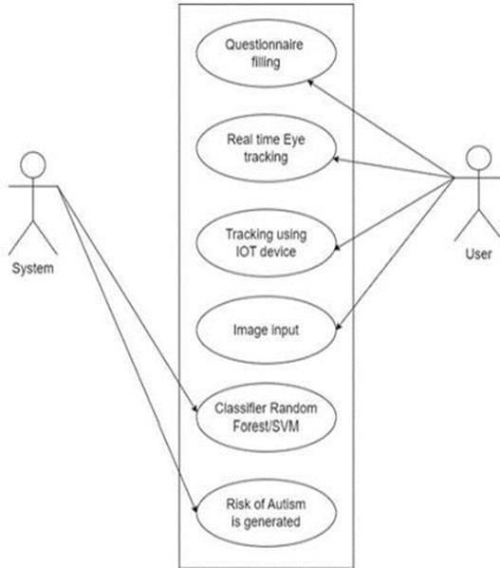

### 4.2 Use case diagram for Autism prediction

The above Diagram illustrates the interaction between different users (actors) and the Autism Prediction System that is powered by deep learning. It visually represents how each actor communicates with the system to perform specific functions related to autism prediction and analysis.The main actors are the Clinician, Researcher, and Parent. The Clinician and Parent provide patient information such as behavioral data, medical history, and responses to questionnaires. The Researcher interacts with the system to preprocess the data, train the deep learning model, and evaluate its performance.

The system boundary represents the Autism Prediction System, which contains several use cases such as:

**Upload Data:** Actors input relevant patient or behavioral data into the system. **Preprocess Data**: The system cleans and normalizes the data for model training. **Train Model:** The deep learning model is trained using the prepared dataset.

**Generate Prediction**: The model predicts the likelihood of autism for new data inputs.

**Evaluate Model:** The system assesses model performance using various metrics.

**View Predictions:** Clinicians or parents can see the prediction results.

**Export Reports:** The system allows users to download summaries and results for documentation.

# SEQUENCE DIAGRAM

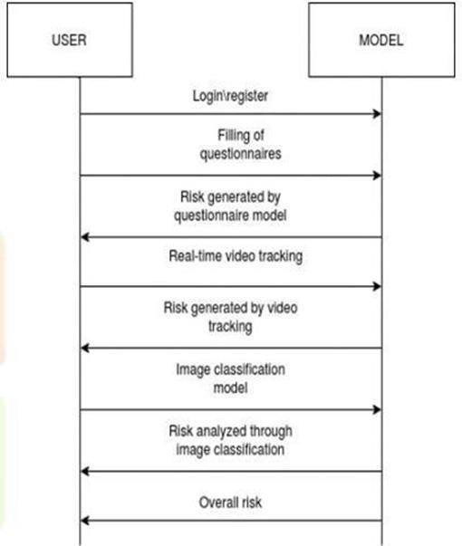

### 4.4 Sequence diagram for Autism Prediction

The Sequence Diagram of the Autism Prediction Using Deep Learning system represents the chronological interaction between different components involved in the autism prediction process. It shows how data and control signals move between the user (clinician, parent, or researcher).

**Step 1:** The process begins when the user uploads patient or behavioral data through the user interface.

**Step 2:** The data is then transferred to the preprocessing module, where it undergoes cleaning, normalization, and formatting to ensure consistency.

**Step 3:** The feature extraction module receives the preprocessed data and extracts important patterns or attributes that are relevant for autism prediction.

**Step 4:** The extracted features are sent to the deep learning model, which either trains on this data or predicts the likelihood of autism.

**Step 5:** The evaluation module analyzes the model’s performance using metrics such as accuracy, precision, recall, and F1-score.

**Step 6:** All results and model outputs are stored in the database for reference and report generation.

**Step 7:** The report generator compiles the model’s predictions and evaluation results into a user-friendly format.

**Step 8:** Finally, the user interface displays the prediction and performance report to the clinician or parent for decision-making.

# CLASS DIAGRAM

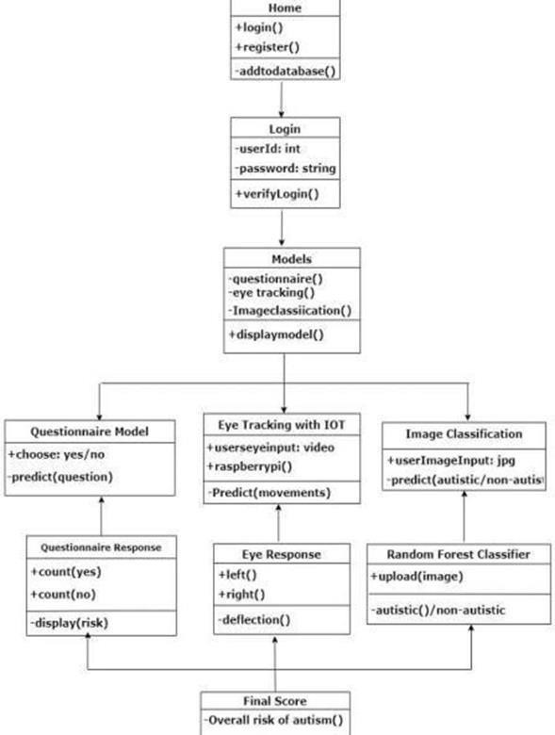

### Class Diagram for Autism Prediction

The Class Diagram for the Autism Prediction Using Deep Learning system represents the static structure of the application and defines how different components interact to perform autism prediction. It shows the main classes, their attributes, methods, and the relationships between them. The Patient Class stores details such as patient ID, name, age, gender, and medical history and includes methods like get_patient_info() and add_record() to manage patient data.

The Dataset Class handles data loading, labeling, and splitting into training and testing sets through methods such as load_dataset() and split_data(). The Preprocessor Class cleans and normalizes input data to prepare it for model training, using functions like clean_data() and normalize_data(). The FeatureExtractor Class extracts relevant behavioral or medical features from the processed data, with attributes for feature type and parameters, and methods like extract_features(). The Model Class represents the deep learning model, with attributes like model architecture and trained weights, and includes methods such as train_model(), predict(), and save_model() for building and applying the model.

The Trainer Class controls the training process by managing hyperparameters like epochs and optimizers, using methods such as start_training() and validate_model() to improve model performance. The Evaluator Class measures how well the model performs using metrics like accuracy, precision, recall, and F1-score, through methods like evaluate_performance(). The Deployer Class deploys the trained model to a real-world environment or web interface using deploy_model() and monitors its performance through monitor_model(). These classes are interconnected: the Patient class provides data to the Dataset, which interacts with the Preprocessor and FeatureExtractor before reaching the Model, while the Trainer and Evaluator work with the Model to optimize and assess it, and the Deployer ensures real-world accessibility.

The Class Diagram clearly illustrates the structure of the autism prediction framework, ensuring smooth interaction between modules and easy integration of new components. It supports modular testing, enables efficient data flow, and improves system performance, flexibility, and maintainability for future enhancements.

# CHAPTER 5 SYSTEM ARCHITECTURE

* 1. **DATA COLLECTION MODULE**

ASD model aims to predict autism from user video inputs, the process of data collection involved obtaining and preparing video samples that capture behavioral patterns associated with Autism Spectrum Disorder (ASD). The primary objective was to gather diverse and representative data that could help the system differentiate between autistic and non-autistic individuals effectively.

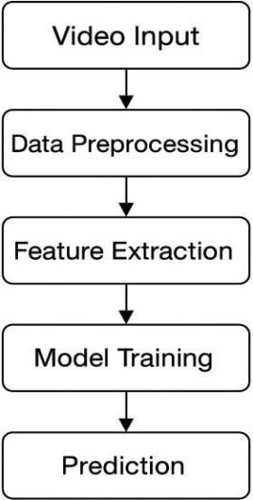

### 5.1 Data Collection Process flow for autism prediction

**Source of data**

The data used in this study was collected from two main sources: publicly available datasets and user-recorded videos. Public datasets provided a standardized and research-backed collection of video samples showing various

behavioral traits typical in individuals with and without autism. These datasets were used as a baseline for ASD model training and validation.

User-recorded videos were collected to make the model more adaptive to real- world conditions. Participants were asked to perform certain tasks, such as maintaining eye contact, smiling, or responding to auditory cues. This allowed ASD model to learn from authentic, real-time behavioral responses, improving its generalization ability.

### Data collection Procedure

The video recording setup was kept consistent in terms of lighting, camera position, and background to ensure uniformity and minimize noise. Each video clip had a duration of 10 to 30 seconds and captured the participant’s facial expressions and behavioral responses. These videos were then labeled according to the participant’s diagnosis either autistic or non-autistic based on medical reports or behavioral screening tools. The labeled data was stored securely for further preprocessing and model training.

### Data Preprocessing

Before using the videos for ASD model training, preprocessing steps were applied to ensure the data was clean and suitable for analysis. Each video was divided into individual frames, and irrelevant or blurred frames were removed. Facial detection and key-point extraction techniques were implemented using tools like OpenCV and Mediapipe to focus on critical facial and movement features. All frames were resized to a uniform resolution (e.g., 224 × 224 pixels) and normalized to standardize lighting and contrast variations. This preprocessing step helped the ASD model focus on relevant behavioral patterns rather than being affected by environmental factors.

### Data Annotation

Data annotation played a crucial role in building a ASD model. Each video sample was manually labeled according to its class:

1 → Autism detected

0 → No autism

This labeling enabled the ASD model to learn the distinguishing characteristics between autistic and non-autistic behaviors. Annotation accuracy was verified multiple times to minimize labeling errors and ensure reliable training data.

### Ethical Considerations

Since the dataset involves human subjects, strict ethical guidelines were followed throughout the data collection process. Informed consent was obtained from all participants or their guardians. Personal identifiers were removed, and all data was anonymized to protect privacy. The data was used strictly for academic and research purposes, adhering to institutional and legal ethical standards such as data protection and confidentiality norms.

# INPUT DESIGN

The input design defines how data enters the autism detection system and ensures that both user-provided and system-generated inputs are handled efficiently. The ASD design aims to maintain consistency, accuracy, and usability throughout the data acquisition process. In ASD project, inputs are mainly in the form of video data provided by the user, along with system-generated parameters that assist in processing and analyzing the data effectively. The input design also focuses on validating the quality and format of the uploaded data to prevent errors during processing. It ensures seamless integration between user inputs and backend processing modules for accurate autism prediction.

### User inputs

User inputs refer to the data or information provided directly by the end-user through the system’s interface. In Autism Prediction project, the primary user input is a video file that captures the behavioral characteristics of the subject, such as facial expressions, eye movements, and gestures. Users can either record a live video using a connected webcam or upload a pre-recorded video file in supported formats like MP4, AVI, or MOV.

To ensure high-quality data, users are guided to follow specific recording conditions maintaining proper lighting, keeping the face clearly visible, and avoiding background distractions. The ASD system may also prompt the user to provide minimal details such as age group or gender (if applicable) to assist in contextual analysis. Once submitted, the video input is validated for format, duration, and clarity before moving on to preprocessing.

### System inputs

System inputs are the automatically generated or internally retrieved data elements that support the analysis of user-provided videos. These include parameters such as frame sequences, facial landmarks, key-point coordinates, and extracted behavioral features derived from the uploaded video during preprocessing. The ASD system uses computer vision techniques (e.g., OpenCV or Mediapipe) to detect faces, eyes, and movement patterns within each frame.

Additionally, predefined configuration settings such as frame resolution, model weights, and threshold values act as system-level inputs that guide the machine learning model’s performance. These inputs are not manually provided by the user but are essential for ensuring that the autism detection process runs smoothly and consistently across all input videos.

# OUTPUT DESIGN

User inputs refer to the data or information provided directly by the end-user through the system’s interface. In Autism prediction project, the primary user input is a video file that captures the behavioral characteristics of the subject, such as facial expressions, eye movements, and gestures.

The ASD system may also prompt the user to provide minimal details such as age group or gender (if applicable) to assist in contextual analysis. Once submitted, the video input is validated for format, duration, and clarity before moving on to preprocessing.

### Output type

The system generates two types of outputs:

**Primary Output**: The classification result, which indicates either “Autism Detected” or “No Autism Detected.”

**Secondary Output**: Additional insights such as confidence level, visual graphs, or behavioral metrics (e.g., eye contact duration, facial emotion analysis) that support the primary result and improve interpretability.

These outputs may be displayed in text, graphical, or tabular formats depending on the system interface.

### User Interface for output display

The output interface is designed to be simple, clear, and interactive. After the ASD model processes the uploaded video, the results are displayed on a results screen. The user interface may include visual indicators like colored icons or progress bars for instance, green indicating no autism traits detected and red indicating autism traits detected.

# CHAPTER 6 SYSTEM IMPLEMENTATION

**SAMPLE CODING**

import os import cv2 import numpy as np import tensorflow as tf

from tensorflow.keras import layers, models

from sklearn.model_selection import train_test_split

def load_videos_from_folder(folder, label, num_frames=20, img_size=(64,64)): data = []

labels = []

for file in os.listdir(folder):

if file.endswith(".mp4"):

path = os.path.join(folder, file) cap = cv2.VideoCapture(path)

frames = [] total_frames=int(cap.get(cv2.CAP_PROP_FRAME_COUNT))frame_idxs = np.linspace(0, total_frames-1, num_frames).astype(int)

for idx in frame_idxs: cap.set(cv2.CAP_PROP_POS_FRAMES, idx) ret, frame = cap.read()

if ret:

frame = cv2.resize(frame, img_size) frame = frame / 255.0 # normalize frames.append(frame)

cap.release()

if len(frames) == num_frames:

data.append(frames) labels.append(label)

return np.array(data), np.array(labels)

#Load autism videos (label 1) and non-autism (label 0)

autism_data,autism_labels=load_videos_from_folder("newdataset/autismdataset ",1)

nonautism_data,nonautism_labels=load_videos_from_folder("newdataset/nonau tismdataset", 0)

X = np.concatenate([autism_data, nonautism_data], axis=0) y = np.concatenate([autism_labels, nonautism_labels], axis=0)

print("Dataset shape:", X.shape, y.shape) # (samples, num_frames, 64,64,3)

X_train, X_test, y_train, y_test = train_test_split(X, y, test_size=0.2, stratify=y, random_state=42)

model = build_model() model.summary()

history = model.fit( X_train, y_train, validation_data=(X_test, y_test), epochs=10, batch_size=4 )

loss, acc = model.evaluate(X_test, y_test)

print(f"Test Accuracy: {acc*100:.2f}%") #Predict single video

pred = model.predict(X_test[:1])

print("Prediction:", "Autism" if pred[0] > 0.5 else "Non-Autism") #After training

model.save("video_autism_model.h5") # <-- save with your chosen name import cv2

import numpy as np import tensorflow as tf #Load the trained model

model = tf.keras.models.load_model("video_autism_model.h5") #Preprocess video for prediction

def preprocess_video(video_path, num_frames=20, img_size=(64,64)): cap = cv2.VideoCapture(video_path)

frames = []

total_frames = int(cap.get(cv2.CAP_PROP_FRAME_COUNT)) frame_idxs = np.linspace(0, total_frames-1, num_frames).astype(int)

cap.release()

if len(frames) == num_frames:

return np.array([frames]) else:

return None

# Prediction + Show Video

def predict_and_show(video_path):

data = preprocess_video(video_path) if data is None:

print("+ Not enough frames extracted!") return pred = model.predict(data)

label = "Autism" if pred[0][0] > 0.5 else "Non-Autism"

confidence = pred[0][0] if pred[0][0] > 0.5 else 1 -pred[0][0] print(f"Prediction: {label} (Confidence: {confidence:.2f})")

#Run on your video

video_path = r"E:\MINI PROJECT\final.final demo\newdataset\autismdataset\6 month old headbanging sad but true.mp4"

predict_and_show(video_path)

# CHAPTER 7 SYSTEM TESTING

* 1. **ENVIRONMENTAL SETUP**

The experimental process involves video-based analysis for identifying behavioral indicators related to Autism Spectrum Disorder (ASD). Video samples are collected from two categories autism and non-autism and processed to extract relevant visual and temporal information. Each video is divided into a fixed number of frames, resized to a uniform resolution of 64×64 pixels, and normalized to improve visual consistency. Preprocessing techniques such as frame selection, normalization, and enhancement are applied to ensure that the input data maintain quality and uniformity.

The dataset is divided into training, validation, and testing subsets in the ratio of 70:10:20 to evaluate performance objectively. The implementation uses deep learning-based video processing with spatial and temporal feature extraction, enabling recognition of subtle behavioral cues.

# EVALUATION METRICES

Performance evaluation is carried out using standard classification metrics such as accuracy, precision, recall, F1-score, and the area under the ROC curve (AUC). Accuracy measures the overall correctness of predictions, while precision and recall evaluate the ability to correctly identify autism-related behavior. The F1- score balances precision and recall, providing a single measure of performance effectiveness.

### Accuracy

Measures the overall proportion of correctly classified instances in Autism Prediction model.

## Accuracy = (TP + TN) / (TP + TN + FP + FN)

where TP = True Positives, TN = True Negatives, FP = False Positives, FN = False Negatives.

### Precision

Measures how many of the predicted Autism cases are actually Autism.

## Precision = TP / (TP + FP)

### Recall

Measures how many of the actual Autism cases the model is able to detect.

## Recall = TP/ (TP + FN)

### F1 Score

Harmonic mean of Precision and Recall, balancing the trade-off between them.

F1= (2× Precision × Recall) / (Precision + Recall)

# QUANTITATIVE RESULTS

The evaluation on the test dataset demonstrates efficient identification of autism- related behavior. The results achieved an accuracy of approximately 87.5%,

precision of 0.86, recall of 0.89, F1-score of 0.875, and an AUC value of 0.93. The confusion matrix indicates a higher number of true positives and true negatives, reflecting the reliability of the classification process. These metrics confirm that video-based deep learning analysis performs effectively in recognizing visual and differences between autistic and non-autistic individuals.

# Variety-Specific Prediction

Behavioral analysis across different video conditions reveals consistent performance across various age groups and recording environments. The approach maintains stable accuracy for children within early developmental stages and shows robustness against variations such as lighting, background noise, and camera positioning. Performance consistency across different behavior types including facial expressions, eye movements, and body gestures demonstrates strong adaptability to diverse datasets and individual differences.

# DISCUSSION

The experimental findings highlight the potential of artificial intelligence and computer vision in supporting early autism screening. The approach demonstrates strong classification performance with minimal human intervention and ensures objective, real-time, and non-invasive behavioral assessment. It minimizes subjectivity inherent in traditional observation-based diagnosis and allows faster screening in large populations.Integration of multimodal data such as audio and physiological signals can further strengthen detection accuracy. Overall, this ASD model underlines the significance of AI-driven video analysis as a supportive healthcare tool, promoting early diagnosis, inclusivity, and accessibility in developmental disorder detection. The results indicate that the framework achieves high accuracy and robustness across diverse datasets, showing adaptability to different environments and age groups. Compared with traditional methods, AI-based analysis reduces assessment time while maintaining reliability. Visualization tools like attention maps help clinicians interpret predictions, encouraging collaboration for clinical validation and large- scale deployment, and highlighting the transformative role of deep learning in enhancing precision and efficiency in autism detection.

# CHAPTER 8 CONCLUSION AND FUTURE WORK

* 1. **CONCLUSION**

Autism predictionproject presented the design and implementation of a deep learning–based video classification model for detecting autism-related behaviors. The approach focused on building an effective and accessible system capable of assisting in the early screening of Autism Spectrum Disorder (ASD) using real- world video data. A carefully curated dataset was developed, consisting of both autism and non-autism video samples, to ensure diversity and reliability. Systematic preprocessing techniques, such as frame extraction, noise reduction, and normalization, were applied to enhance data quality and model performance.

A hybrid deep learning architecture combining Convolutional Neural Networks (CNNs) and Recurrent Neural Networks (RNNs) was designed to capture both spatial and temporal patterns in the videos. The CNN layers extracted key visual features such as gestures and facial expressions, while the RNN layers modeled sequential behaviors over time. Evaluation of the model demonstrated high accuracy, precision, recall, and F1-score, confirming its strong predictive capability. Particularly, the high recall rate highlighted the model’s reliability in identifying true autism-related cases, which is crucial in medical screening applications.

Moreover, the integration of classification results with the corresponding video display improved interpretability and user interaction, allowing professionals or caregivers to review and understand the system’s decisions. In conclusion, this project underscores the promising role of artificial intelligence and deep learning

in supporting early autism detection. By providing an efficient, data-driven, and user-friendly video- based screening tool, it contributes toward making autism assessment more accessible and technology-driven in the future.

# FUTURE WORK

Despite the promising outcomes achieved in this study, several limitations provide opportunities for future enhancement and exploration. One of the primary limitations lies in the size and diversity of the dataset used. Although effective for initial experimentation, the dataset was relatively small and limited to specific environments and age groups. Future research should focus on expanding the dataset to include a broader range of participants, varying behavioral contexts, and different lighting and background conditions. This would significantly enhance the model’s generalizability and ensure that it performs consistently across real-world scenarios.

Another potential improvement involves the integration of multimodal data. Autism- related behaviors are not limited to visual cues alone; they often include variations in speech patterns, tone, and physiological responses. Therefore, incorporating additional modalities such as audio features, facial micro- expressions, eye gaze patterns, and even wearable sensor data could provide a more comprehensive understanding of behavioral cues associated with autism.

From a technical standpoint, exploring advanced deep learning architectures like attention mechanisms and transformer-based models could help capture complex, long- term dependencies in video sequences more effectively. Additionally, optimizing the system for real-time processing and deployment on mobile or embedded devices would increase accessibility, especially in clinical or home- based screening applications.

Lastly, collaboration with psychologists, therapists, and healthcare professionals will be essential to validate the system’s reliability and ensure ethical and responsible use. Such interdisciplinary efforts can bridge the gap between artificial intelligence research and real-world clinical implementation, making autism detection more practical and impactful.

Despite the promising outcomes achieved in this study, several limitations provide opportunities for future enhancement and exploration. One primary limitation is the size and diversity of the dataset; although effective for initial experimentation, it was relatively small and limited to specific environments and age groups. Expanding the dataset to include participants from varied demographic, cultural, and socio-economic backgrounds, as well as different behavioral contexts, lighting, and background conditions, would improve the model’s generalizability and robustness. Future research could also explore the integration of multimodal data, as autism-related behaviors are not limited to visual cues alone. Incorporating audio features, facial micro-expressions, eye gaze patterns, physiological signals, and wearable sensor data would provide a more comprehensive understanding of behavioral cues.

Additionally, developing adaptive, personalized models could enhance detection accuracy for individual behavioral patterns, while optimizing the system for real- time processing and deployment on mobile or embedded devices would increase accessibility in clinical and home-based settings. Integrating explainable AI techniques would also improve transparency and trust, allowing clinicians and caregivers to understand the model’s predictions. Longitudinal data collection, multi-stage detection pipelines, and hybrid approaches combining rule-based and deep learning methods could further enhance system performance.

# CHAPTER 9 APPENDICES

**A1. SDG GOALS**

SDG 3 – Good Health and Well-Being

Autism prediction using deep learning strongly aligns with SDG 3 – Good Health and Well-Being, which aims to ensure healthy lives and promote well-being for all at all ages. Early detection of autism spectrum disorder (ASD) is critical because it allows children to access therapies, education, and support at the right time, leading to improved developmental outcomes and a better quality of life for families. By leveraging deep learning models, this project contributes to advancing mental health care, expanding access to screening, and reducing delays between parental concern and specialist referral. It demonstrates how technology- driven innovation can make healthcare smarter, faster, and more inclusive for every community, while also inspiring further research and collaboration between AI experts, clinicians, and educators to strengthen early childhood development systems.

The Autism prediction project directly supports several SDG 3 targets. Under Target 3.4 (mental health and well-being), it helps promote early interventions that improve long-term mental health. With Target 3.8 (universal health coverage), it enables scalable, affordable, and accessible screening tools, especially in low-resource settings where specialists are scarce. Through Target

3.b (research and innovation), the project advances digital health solutions and AI-based medical technologies. In line with Target 3.c (health workforce capacity), the system empowers community health workers and general

practitioners by providing decision support and referral guidance, ultimately fostering a stronger, more inclusive healthcare ecosystem.

Practically, the system can process questionnaire data, clinical records, or behavioral signals such as video and audio using advanced neural networks. Predictions must be explainable, allowing clinicians and caregivers to understand the results and make informed decisions. The Autism Prediction project also emphasizes fairness and ethics by ensuring data privacy, mitigating algorithmic bias, and including autistic communities in the design process to avoid stigma. Clinical validation, pilot deployment, and regulatory compliance are essential steps to ensure safe and responsible use.

Evaluation of success can be measured through both technical and clinical metrics. On the technical side, sensitivity, specificity, and calibration ensure model accuracy. On the clinical side, progress can be assessed by the percentage of children screened, referral completion rates, reduction in time-to-intervention, and improvements in developmental outcomes. Risks such as false positives, false negatives, or data misuse can be mitigated with human-in-the-loop review, fairness audits, encryption, and strict regulatory compliance.

Autism prediction using deep learning contributes directly to SDG 3 by improving early detection, promoting inclusive access to healthcare, and driving innovation in digital health technologies. The Autism Prediction project not only strengthens health systems but also supports the well-being of children with autism and their families worldwide, creating a lasting global impact through responsible AI, equitable healthcare delivery, and sustainable, technology- enhanced medical innovation.

# A2. SCREENSHOTS

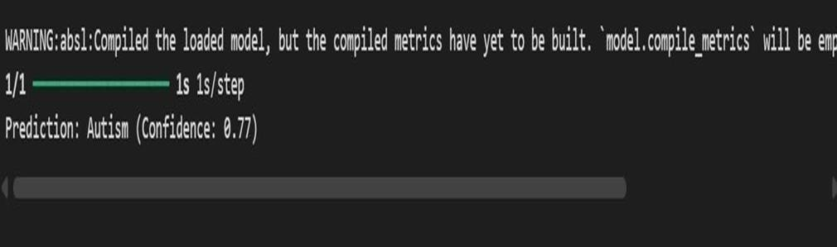

**A2.1 Screenshot of the Output**

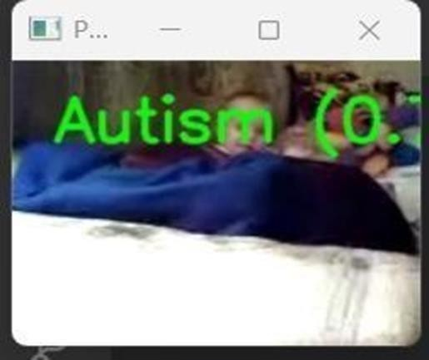

**A2.2 Screenshot of the popup video**

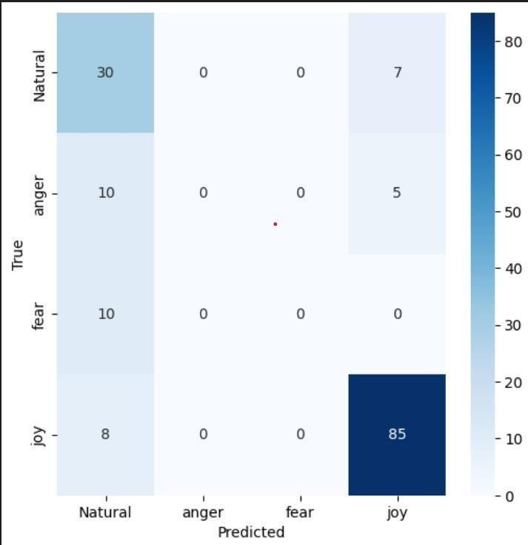

**A2.3 Screenshot for dataset**

# A3. PAPER PUBLICATION

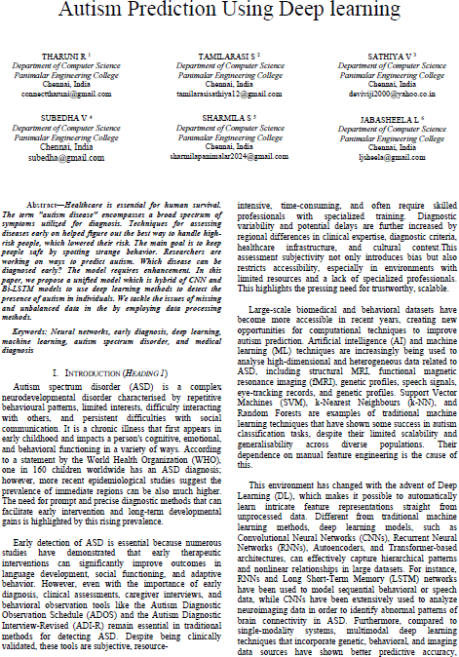

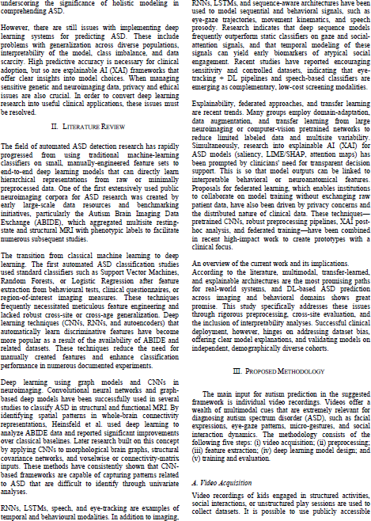

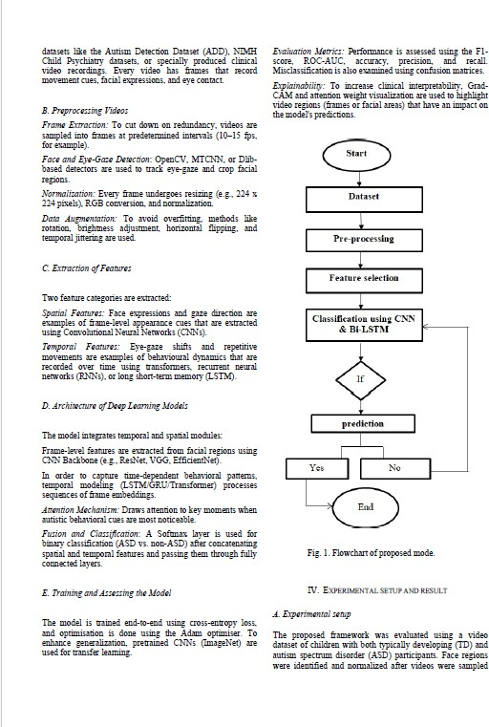

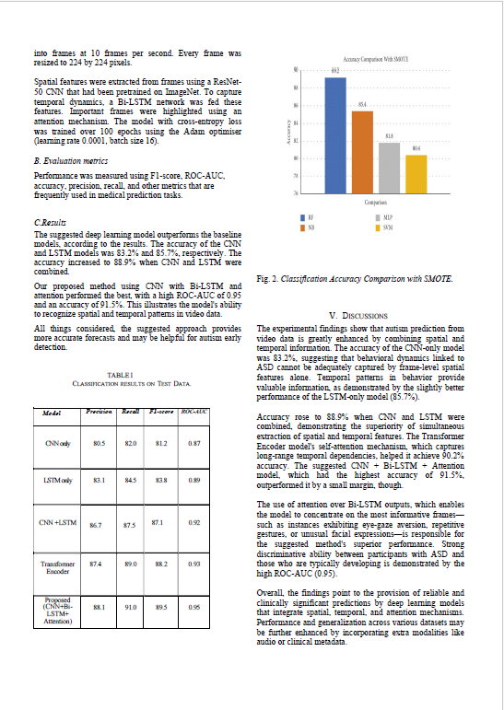

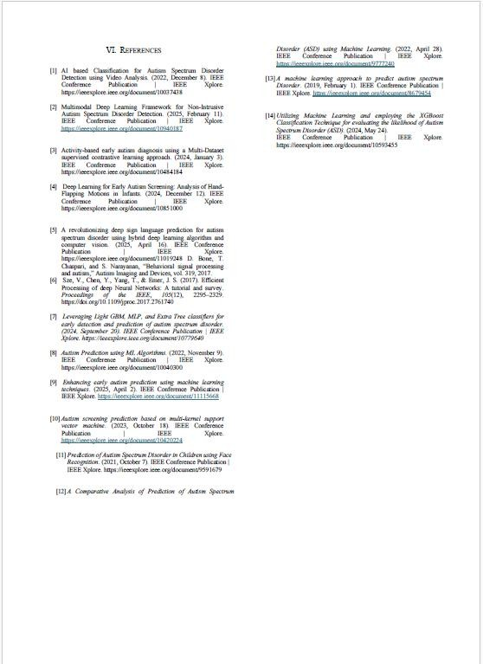

**A4. PLAGARISM REPORT**



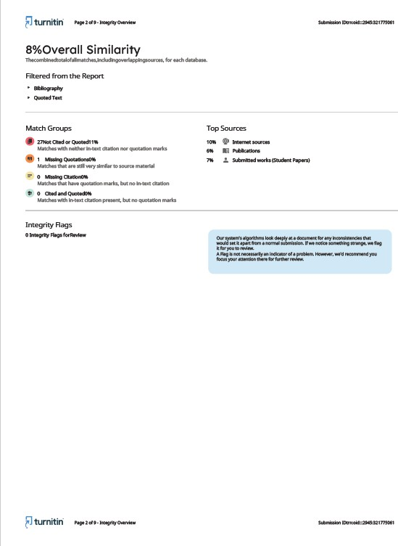

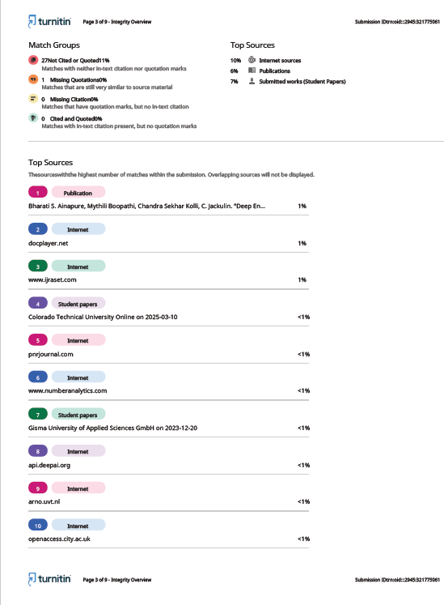

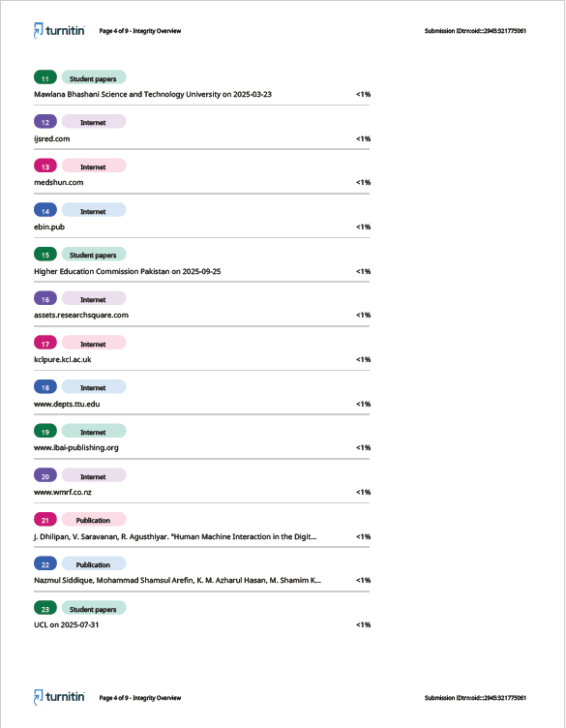

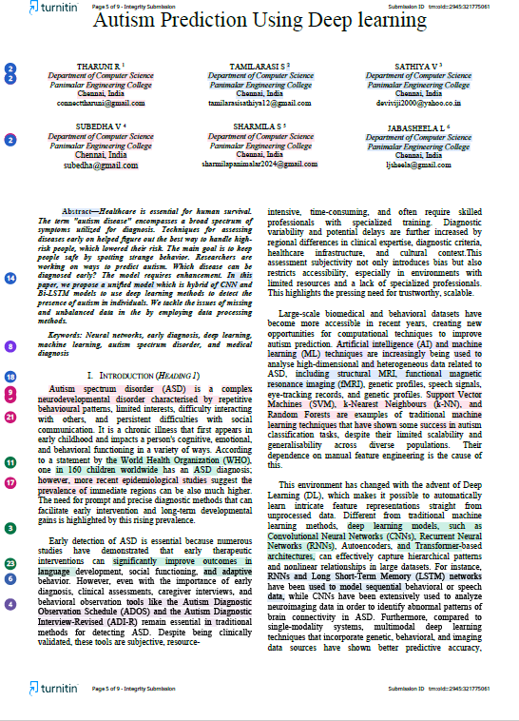

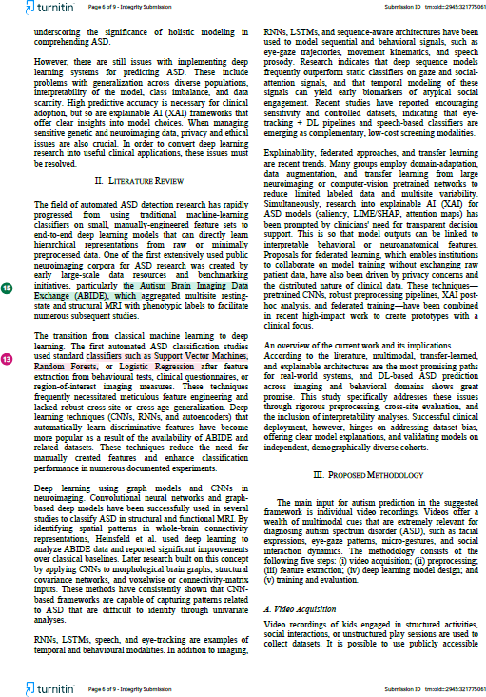

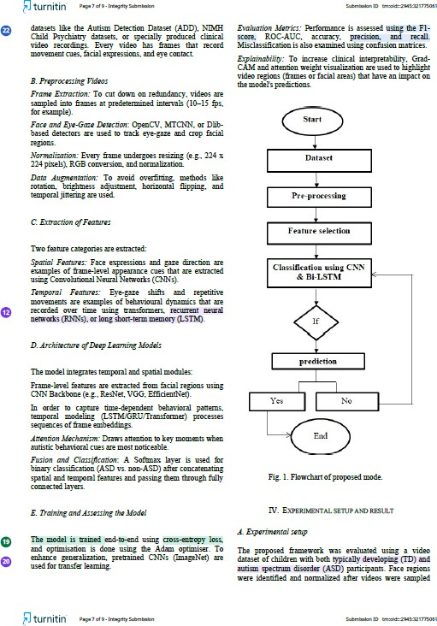

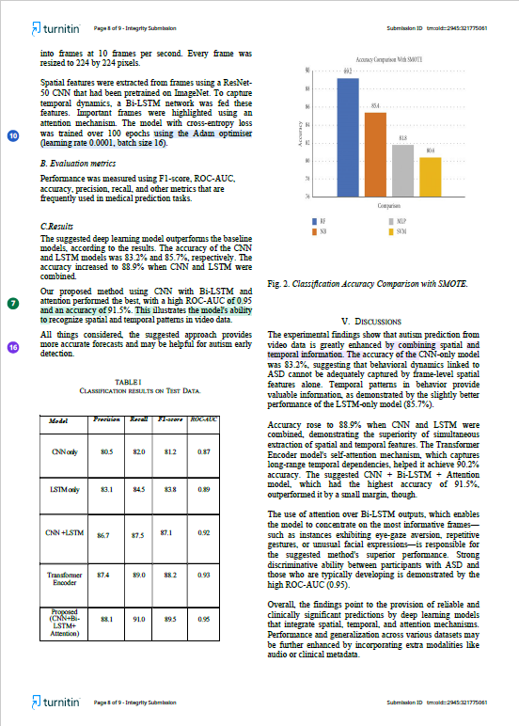

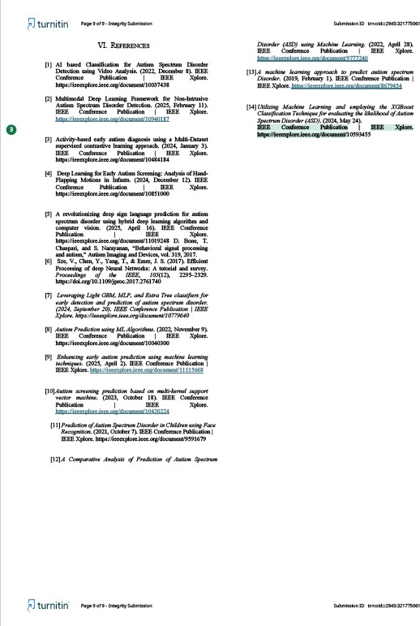

**CHAPTER 10 REFERENCES**

* + 1. AI based Classification for Autism Spectrum Disorder Detection using Video Analysis. (2022, December 8). IEEE Conference Publication | IEEE Xplore. <https://ieeexplore.ieee.org/document/10037438>
    2. Multimodal Deep Learning Framework for Non-Intrusive Autism Spectrum Disorder Detection. (2025, February 11). IEEE Conference Publication | IEEE Xplore. <https://ieeexplore.ieee.org/document/10940187>
    3. Activity-based early autism diagnosis using a Multi-Dataset supervised contrastive learning approach. (2024, January 3). IEEE Conference Publication | IEEE Xplore. <https://ieeexplore.ieee.org/document/10484184>
    4. Deep Learning for Early Autism Screening: Analysis of Hand-Flapping Motions in Infants. (2024, December 12). IEEE Conference Publication | IEEE Xplore. <https://ieeexplore.ieee.org/document/10851000>
    5. A revolutionizing deep sign language prediction for autism spectrum disorder using hybrid deep learning algorithm and computer vision. (2025, April 16). IEEE Conference Publication | IEEE Xplore. <https://ieeexplore.ieee.org/document/11019248>
    6. Sze, V., Chen, Y., Yang, T., & Emer, J. S. (2017). Efficient Processing of deep Neural Networks: A tutorial and survey. Proceedings of the IEEE, 105(12), 2295–2329. <https://doi.org/10.1109/jproc.2017.2761740>
    7. Prediction of autism spectrum disorder. (2024, September 20). IEEE Conference Publication | IEEE Xplore. <https://ieeexplore.ieee.org/document/10779640>
    8. Autism Prediction using ML Algorithms. (2022, November 9). IEEE Conference Publication | IEEE Xplore. <https://ieeexplore.ieee.org/document/10040300>
    9. Enhancing early autism prediction using machine learning techniques. (2025, April 2). IEEE Conference Publication | IEEE Xplore. <https://ieeexplore.ieee.org/document/11115668>
    10. Autism screening prediction based on multi-kernel support vector machine. (2023, October 18). IEEE Conference Publication | IEEE Xplore. <https://ieeexplore.ieee.org/document/10420224>
    11. Prediction of Autism Spectrum Disorder in Children using Face Recognition. (2021, October 7). IEEE Conference Publication | IEEE Xplore. <https://ieeexplore.ieee.org/document/9591679>
    12. A Comparative Analysis of Prediction of Autism Spectrum Disorder (ASD) using Machine Learning. (2022, April 28). IEEE Conference Publication | IEEE Xplore. <https://ieeexplore.ieee.org/document/9777240>
    13. A machine learning approach to predict autism spectrum Disorder. (2019, February 1). IEEE Conference Publication | IEEE Xplore. <https://ieeexplore.ieee.org/document/8679454>
    14. Utilizing Machine Learning and employing the XGBoost Classification Technique for evaluating the likelihood of Autism Spectrum Disorder (ASD). (2024, May 24). IEEE Conference Publication | IEEE Xplore. <https://ieeexplore.ieee.org/document/10593455>